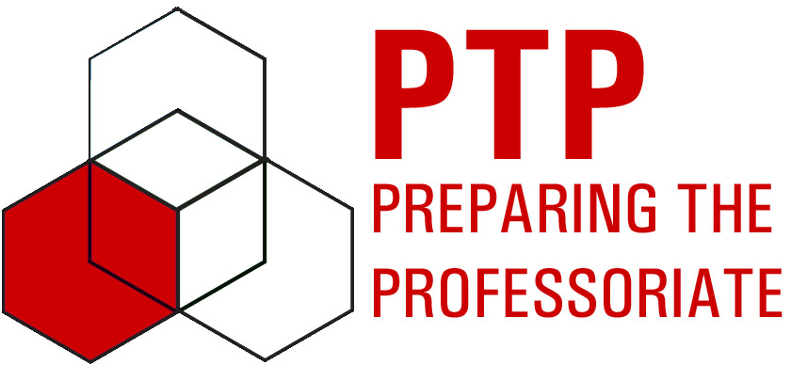
Zach Abernathy Post-Observation Report

I observed Zach Abernathy’s class, Applied Differential Equations II, on March 29, 2011 as part of the PTP peer observation process. The class was learning about the two-dimensional heat equation and the class activities included lecture, an example problem applying lecture material, and the use of Maple to animate the solution so that the class could see how the temperature distribution on a plate changed over time. I took notes in the form of an observation log on this class.

I noticed several effective moments in Zach’s class. He asked many questions of the students as he was deriving the solution to the 2-D heat equation, keeping them focused and engaged in the lesson. He also allowed students to ask questions at any time, some of which generated discussion about the solution to the equation and how the equation could be applied in real-world scenarios. Additionally, using Maple to animate the solution was a great way for the students to visually grasp the concepts taught and see how heat flows through a plate given a set of initial and boundary conditions.

Zach and I talked about the class in a post-observation meeting on Friday, April 1, 2011. Our discussion focused on key strengths and weaknesses of his teaching effectiveness during the class. We discussed the use of Maple as an instructional tool and the impact that it had on student attention and understanding of the concepts covered in lecture. We also talked about the use of questions to draw students into the lecture. Several areas for improvement were noted, including facing the class while lecturing rather than the board and observing the students to determine if they were paying attention to the lecture. Zach was surprised to find out that several of the students were texting or nodding off during the lecture and made a note to keep an eye on those students in the future.

During that meeting, Zach identified two goals for his future teaching: to continue to incorporate instructional technology during lecture and to increase time spent facing and talking to the class. Working towards these goals will help him be a more effective instructor, as they enable him to engage students’ attention, help them visualize concepts, and gauge their understanding of concepts as they are taught in lecture. These goals show that Zach is dedicated to improving his teaching effectiveness and willing to adapt his teaching style to fit the needs of his students.

